Marty the Clownfish

Marty was sad in the sea. As a clownfish, he felt like he should be funny. As a clownfish, he was not funny.

He was not funny at all. He was very serious and did not make anyone laugh.

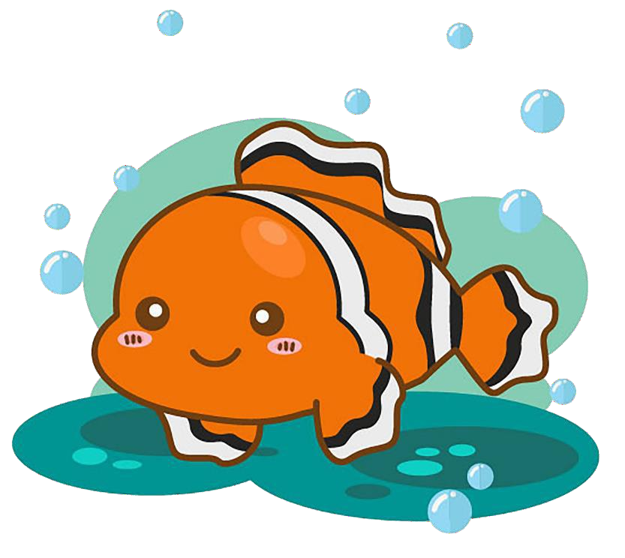He told jokes to the lionfish, but they did not laugh. He told jokes to the dogfish, but they did not laugh either.

“I am a clownfish, and I should be funny,” Marty said aloud.

“You don’t have to be funny,” said a shark from

nearby. “You are kind and helpful. You are friendly and smart.”

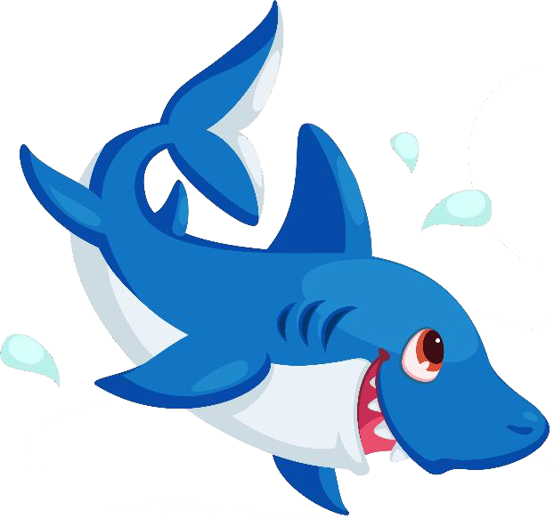“But clowns make people laugh, so a clownfish should make fish laugh,” said Marty.

“The lionfish do not act like lions.

The dogfish do not act like

dogs,” the shark told him.

“Marty, just be yourself.”

So, Marty did just that. He stopped trying to tell jokes. Soon, the fish all liked him. Soon, he had a lot of fish friends.

One day, Marty said, “I am going to tell you all a joke.”

“Marty, no! No more jokes!” Marty said, “Just kidding!”